38.47: Eq. (38.32): 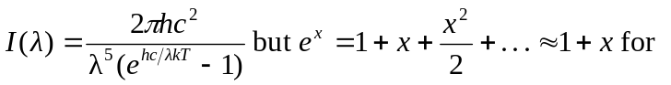
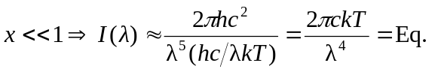(38.31), which is Rayleigh’s distribution.

